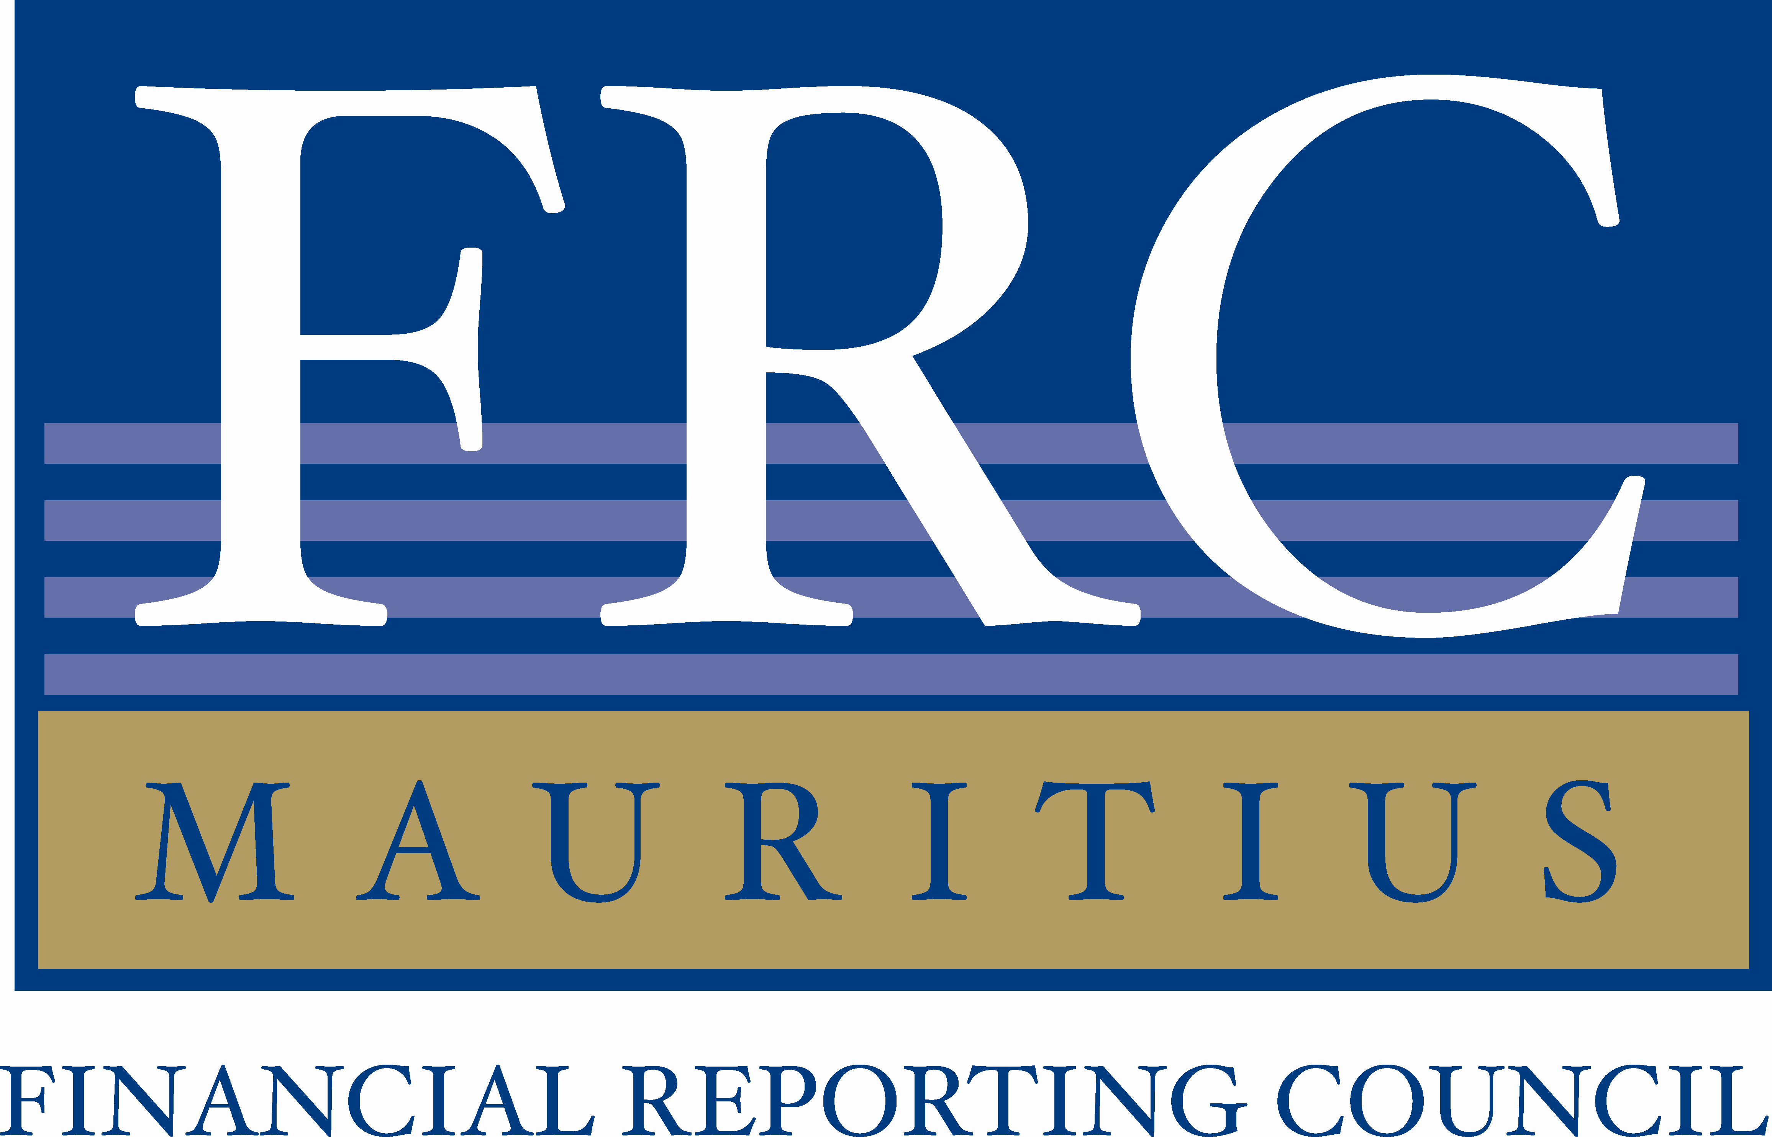 | FINANCIAL REPORTING COUNCIL  Tel: (230) 213 6800, Fax: (230) 213 6900, secretariat@frcmauriius.org

VACANCY

The Financial Reporting Council (FRC) hereby invites applications from suitable, dynamic and talented candidates for the following posts:

- Technical Officer (Ref: TO/FRC/2024)
- Financial Operations Officer (Ref: FOO/FRC/2024)
- Management Support Officer (Ref: MSO/FRC/2024)

Mode of Application:  For  - Technical Officer &  - Financial Operations Officer  For  Management  Support Officer |  | Application in sealed envelope should be sent with full Curriculum Vitae, a motivation letter, photocopies of original certificates and a recent passport size photo.  Application form in sealed envelope should be submitted along with photocopies of certificates and a recent passport size photo to the FRC. The application form is available at the reception desk of FRC or can be downloaded from the FRC’s website (https://frc.govmu.org).
All applications should be sent to the Chief Executive Officer, Financial Reporting Council, 3rd Floor, Anglo Mauritius House, Intendance Street, Port Louis at latest by 7 June 2024. Clearly indicating at the right-hand corner of the envelope the post applied.

Notes:
- The Job description pertaining to the above posts can be viewed on our website (http://frc.govmu.org);
- Short listed candidates may be requested to submit a Character Certificate;
- Late applications will not be considered;
- Only the best qualified candidates will be called for interview; and
- FRC reserves the right not to make any appointment following this advertisement.

16 May 2024

